Assignment 07

Linux os & scripting – b keerthana

AMRUTHESH

241059041

M.E – Cyber Security

MSIS, MANIPAL

**1. Count how many packets use each protocol (TCP, UDP, ICMP)**

awk -F, '{protocol_count[$4]++} END {for (protocol in protocol_count) print protocol, protocol_count[protocol]}' network_traffic.csv

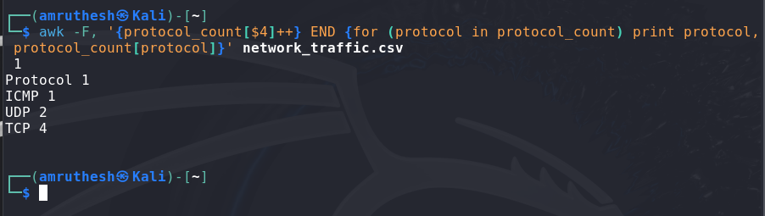

**2. Filter and print only the dropped packets.**

awk -F, '$8 == "Dropped" {print}' network_traffic.csv

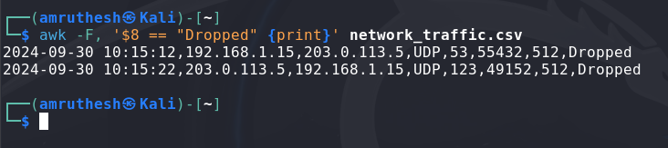

**3. Print the Timestamp, Source_IP, Destination_IP, and Packet_Size for packets with** **size > 1000 bytes.**

awk -F, '$7 > 1000 {print $1, $2, $3, $7}' network_traffic.csv

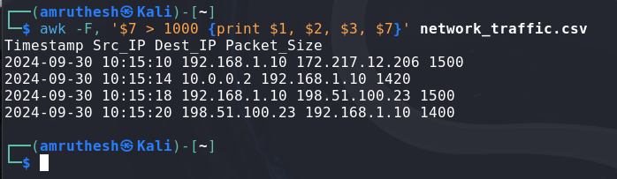

**4. Display traffic directed to destination port 443.**

awk -F, '$6 == 443 {print}' network_traffic.csv

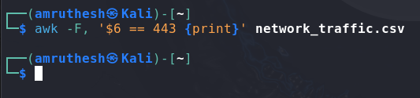

**5. Print all unique Source_IP addresses.**

awk -F, '{ips[$2]++} END {for (ip in ips) print ip}' network_traffic.csv

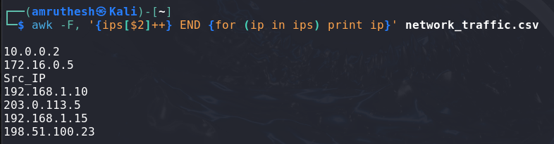

**6. Filter only TCP traffic and calculate the average packet size.**

awk -F, '$4 == "TCP" {sum += $7; count++} END {if (count > 0) print "Average TCP Packet Size:", sum / count}' network_traffic.csv

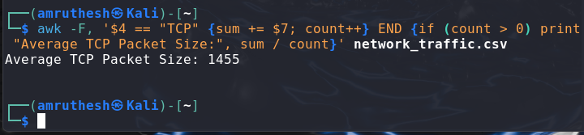

**7. Count invalid records (missing or malformed fields).**

awk -F, 'NF != 8 || !($4 ~ /^(TCP|UDP|ICMP)$/) || $7 !~ /^[0-9]+$/ {invalid++} END {print "Invalid Records:", invalid+0}' network_traffic.csv

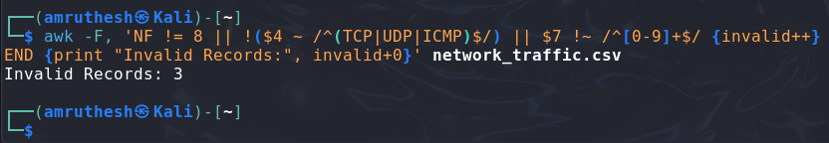

**8. Extract and print rows where Source_IP is in the 192.168.x.x range.**

awk -F, '$2 ~ /^192\.168\./ {print}' network_traffic.csv

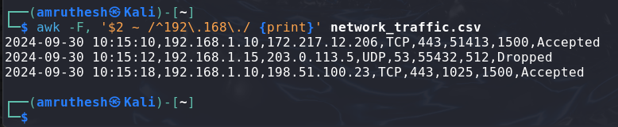

**9. Match traffic directed to either port 80 (HTTP) or port 443 (HTTPS).**

awk -F, '$6 == 80 || $6 == 443 {print}' network_traffic.csv

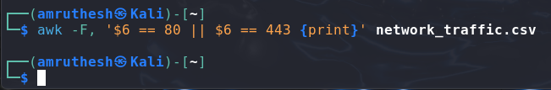

**10. Filter out rows where the Destination_Port contains any alphanumeric characters.**

awk -F, '$6 ~ /^[0-9]+$/ {print}' network_traffic.csv

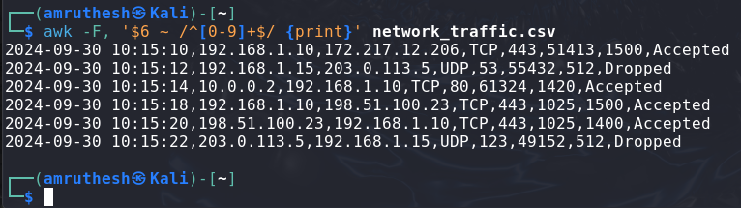

**11. Filter out traffic where the protocol is TCP AND the destination port is 443.**

awk -F, '!($4 == "TCP" && $6 == 443) {print}' network_traffic.csv

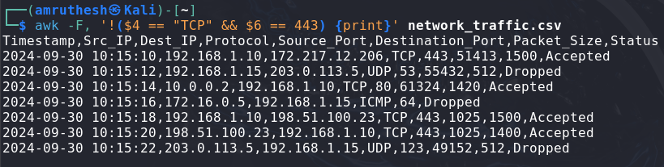

**12. Filter out and print traffic where the Packet_Size is > 1000 OR the Status is Dropped.**

awk -F, '$7 > 1000 || $8 == "Dropped" {print}' network_traffic.csv

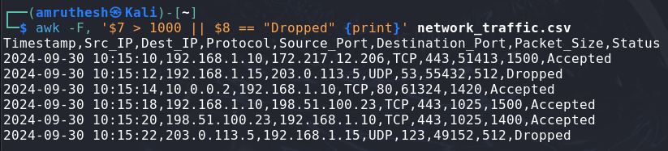

**13. Print traffic NOT originating from 192.168.x.x IP addresses.**

awk -F, '$2 !~ /^192\.168\./ {print}' network_traffic.csv

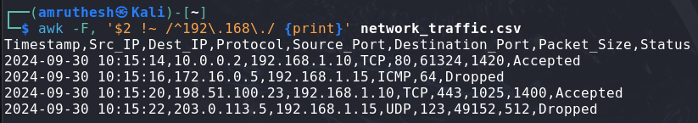

**14. Filter rows where both Source_IP and Destination_IP are within the 192.168.x.x range.**

awk -F, '$2 ~ /^192\.168\./ && $3 ~ /^192\.168\./ {print}' network_traffic.csv

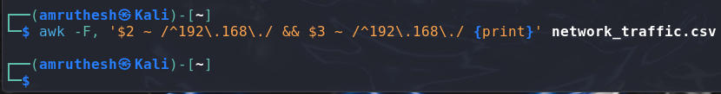

**15. Filter out traffic where the destination port is 22 OR the packet size is less than 100** **bytes.**

awk -F, '!($6 == 22 || $7 < 100) {print}' network_traffic.csv

